Number of death in Arizona by heart diseases
https://pub.azdhs.gov/health-stats/menu/info/trend/index.php?pg=deaths
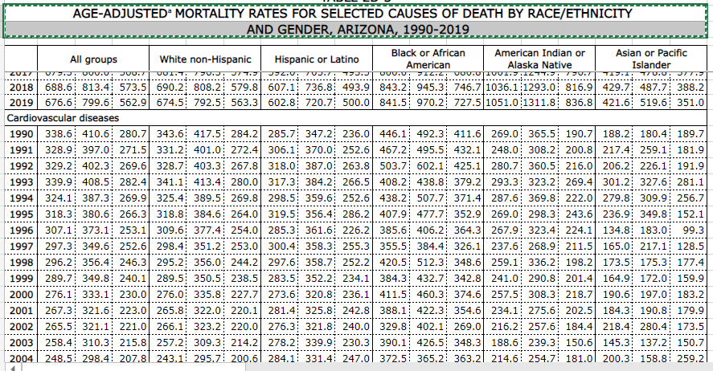
Number of death by gender
https://pub.azdhs.gov/health-stats/menu/info/trend/index.php?pg=deaths
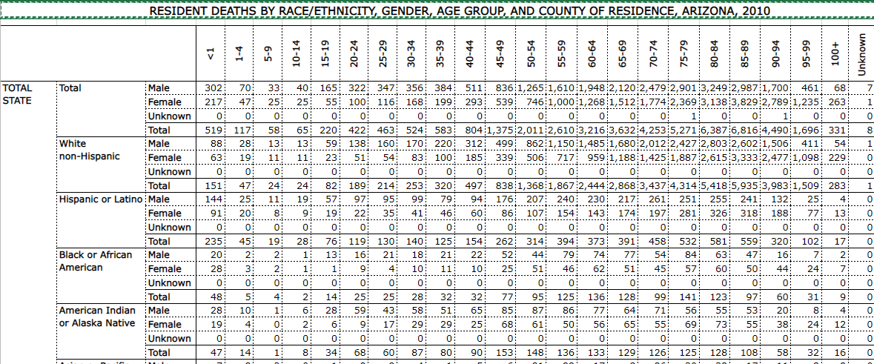
Household income in metropolitan area AZ
https://censusreporter.org/profiles/31000US38060-phoenix-mesa-chandler-az-metro-area/
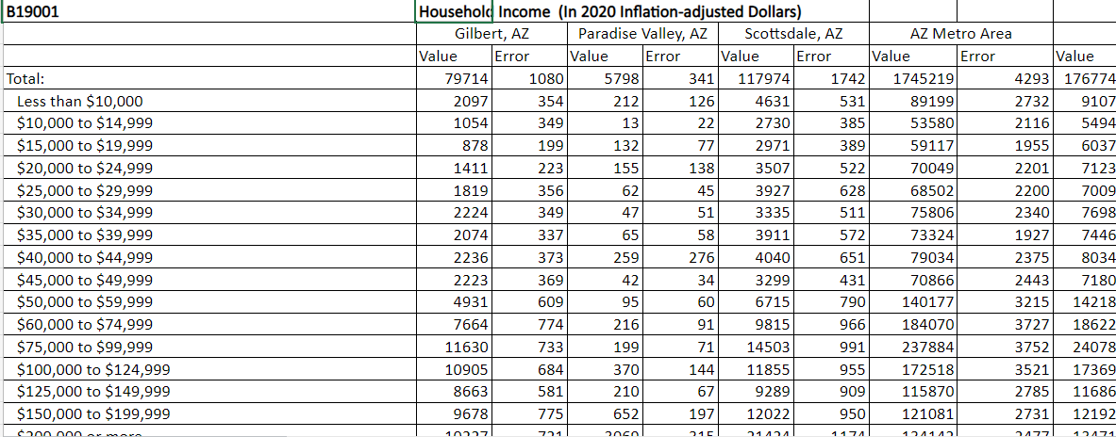

Cost of heart disease treatement
https://mcforms.mayo.edu/mc6500-mc6599/mc6507-15.pdf
https://www.mayoclinic.org/patient-visitor-guide/billing-insurance/price-estimates/arizona-price-transparency

https://wonder.cdc.gov/mortSQL.html

Heart diseases and stroke in Arizona
https://azdhs.gov/documents/prevention/tobacco-chronic-disease/heart-disease-burden-report-2019.pdf

The Burden of Cardiovascular Disease in Arizona
https://azdhs.gov/documents/prevention/tobacco-chronic-disease/az-heart-disease-stroke/az-burden-of-cardiovascular-disease.pdf

Cost analysis of treating cardiovascular diseases in a super-specialty hospital

https://www.ncbi.nlm.nih.gov/pmc/articles/PMC8730466/#:~:text=According%20to%20a%20study%20conducted,of%20total%20costs%20%5B21%5D.

